6.2.1: MOBILE DEVICE POLICY – E1

CONTROL REQUIREMENTS OVERVIEW

6.2.1: Mobile Device Policy - Scope
Technology teams [WHO] have defined a policy and implemented supporting security measures to manage the risks resulting from mobile devices [WHAT] which can be used to access the organisation's systems, services and information [WHERE] to prevent unauthorised access to and loss of sensitive data through mobile devices [WHY]. This includes but is not limited to
- the definition of accepted vs. not accepted mobile devices and hardware / software releases;
- defined security requirements which must be met prior to granting access to the organisation's systems, services and information via mobile devices.
- the registration of mobile devices for which access to the organisation's systems, services and information has been granted.
- measures to protect information stored on the device and unauthorised access in case of theft or loss including remote wiping; and
- defined rules on acceptable use which have been published to end users [WHAT].

6.2.1 – Test Sample to Include
Test sample to include:
- - laptop owned by the organisation
- - smartphone / tablet owned by the organisation

6.2.1 - CSB Requirements
[D1] Standards defining which mobile devices and hardware / software releases are accepted to access the organisations systems, services and information are in place, have been communicated and are being updated as required.
[E1] A) Copy of mobile device policy / standard document defining which mobile devices and hardware / software releases are accepted to access the organisations systems, services and information.
B) Evidence that the policy / standard is reviewed and updated as required and has been made available for key stakeholders.

1.1 [E1]
[D1] Standards defining which mobile devices and hardware / software releases are accepted to access the organisations systems, services and information are in place, have been communicated and are being updated as required.

[E1] A) Copy of mobile device policy / standard document defining which mobile devices and hardware / software releases are accepted to access the organisations systems, services and information.
B) Evidence that the policy / standard is reviewed and updated as required and has been made available for key stakeholders.
1.1.1 | Provide with a copy of the Mobile Device Policy.
EVIDENCE [E1]: SAMPLE 1.1.1-1: Below attached a copy of the Mobile Device Management policy – RDC-BIT-PRC-0097

EVIDENCE [E1]: SAMPLE 1.1.1-2: Evidence demonstrating approval of the policy.
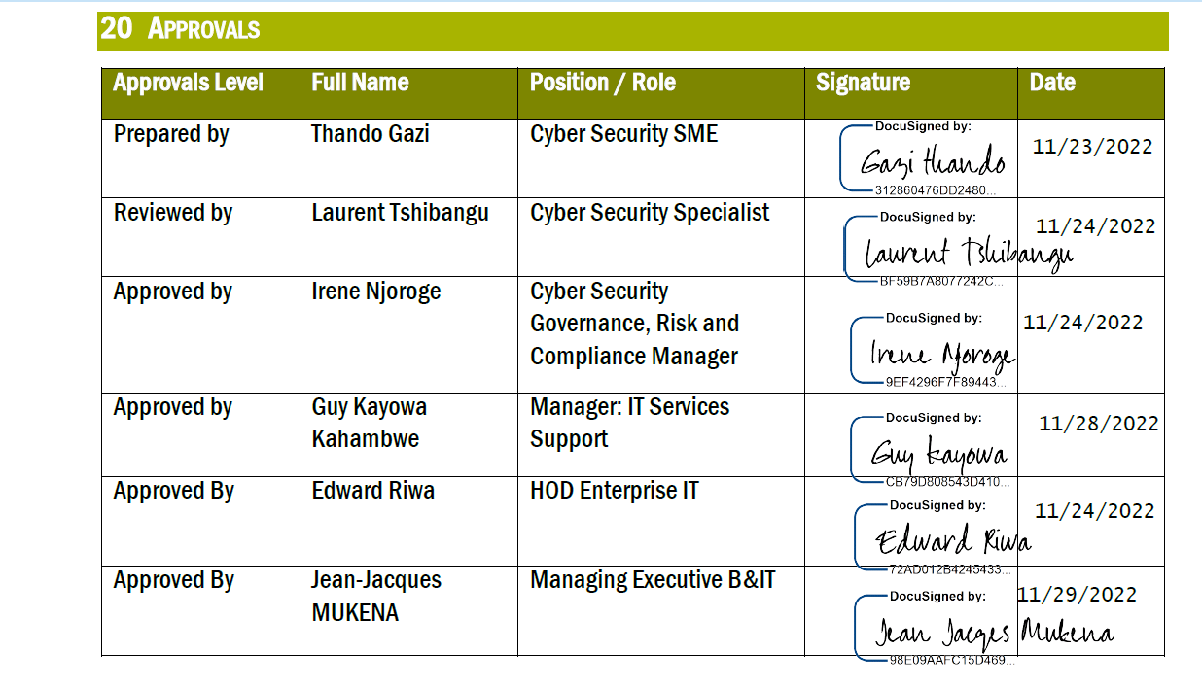

EVIDENCE [E1]: SAMPLE 1.1.1-3: Evidence demonstrating revision history of the policy.
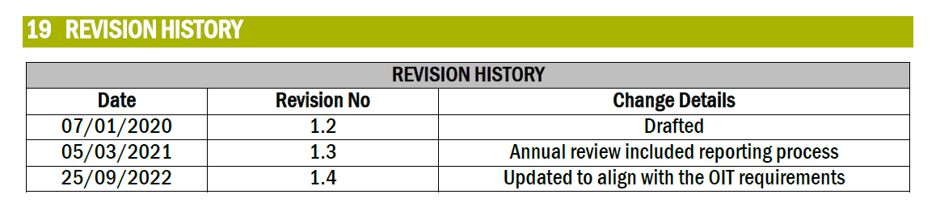
1.1.2. | Provide a copy of mobile device policy / standard document defining which mobile devices and hardware / software releases are accepted to access the organisations systems, services and information
EVIDENCE [E1]: SAMPLE 1.1.2-1: Extract from the Mobile Device Management Policy “Annexure A” defining which mobile devices and hardware / software releases are accepted to access the organisation systems.
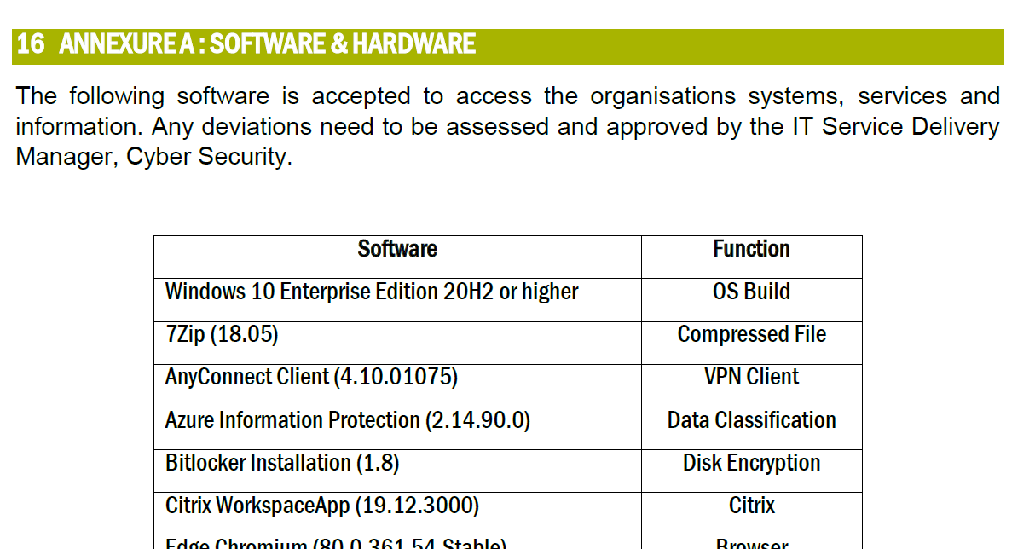

1.1.3. | Evidence that the policy / standard is reviewed and updated as required and has been made available for key stakeholders.
EVIDENCE [E1]: SAMPLE 1.1.3-1: Evidence of email notification from Internal Communication informing users of the VIC mass migration.
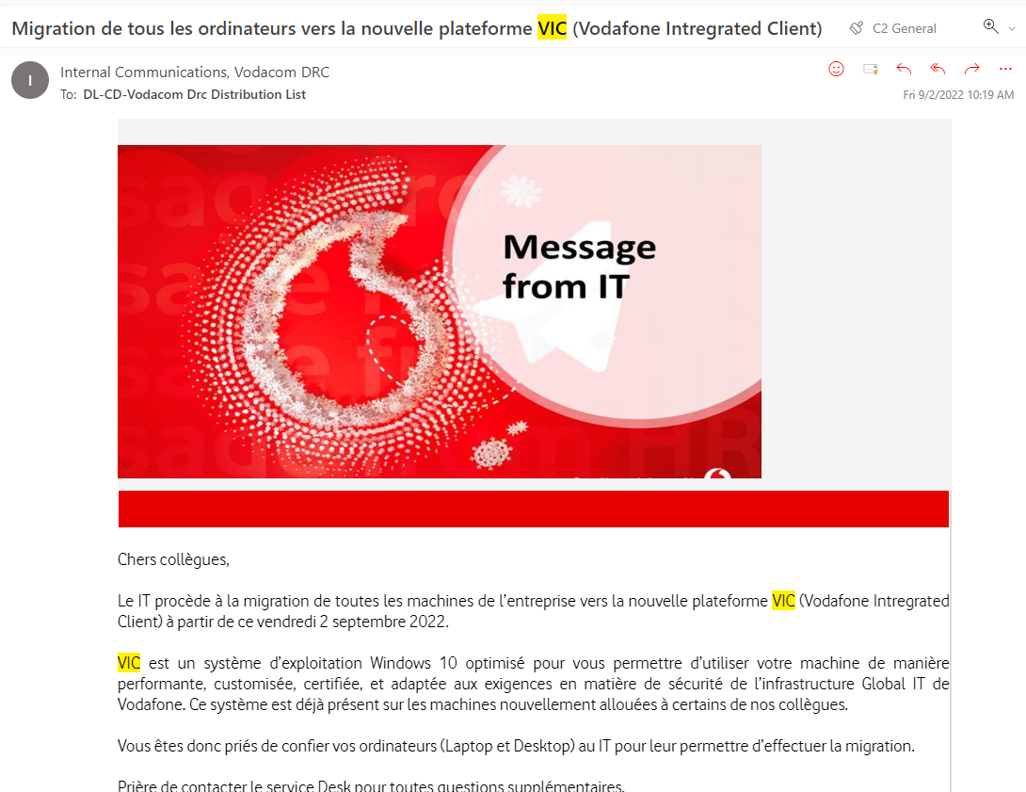

EVIDENCE [E1]: SAMPLE 1.1.3-2: Evidence of email notification from Internal Communication informing users of the Intune OS policy update for which users are required to upgrade their devices to the supported OS version to continue consuming Vodafone services through their mobile phone.
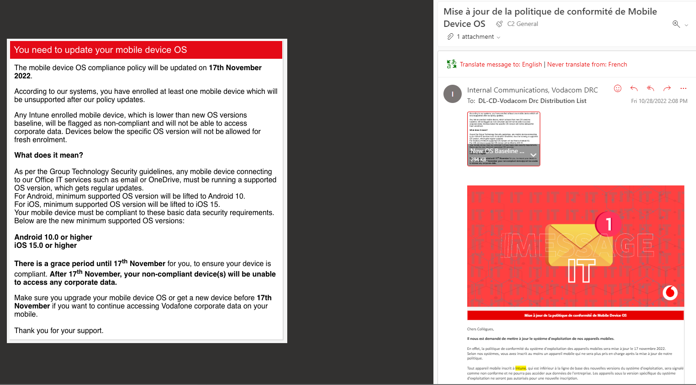
EVIDENCE [E1]: SAMPLE 1.1.3-3 Vodacom DRC policies and processes are published on the Internal SharePoint. Extract below from SharePoint confirming that the Mobile Device Management Policy has been published.
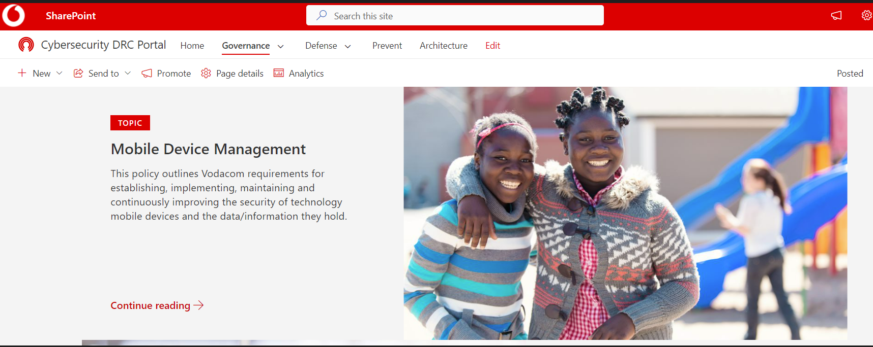

---------------------------End of Document---------------------------

